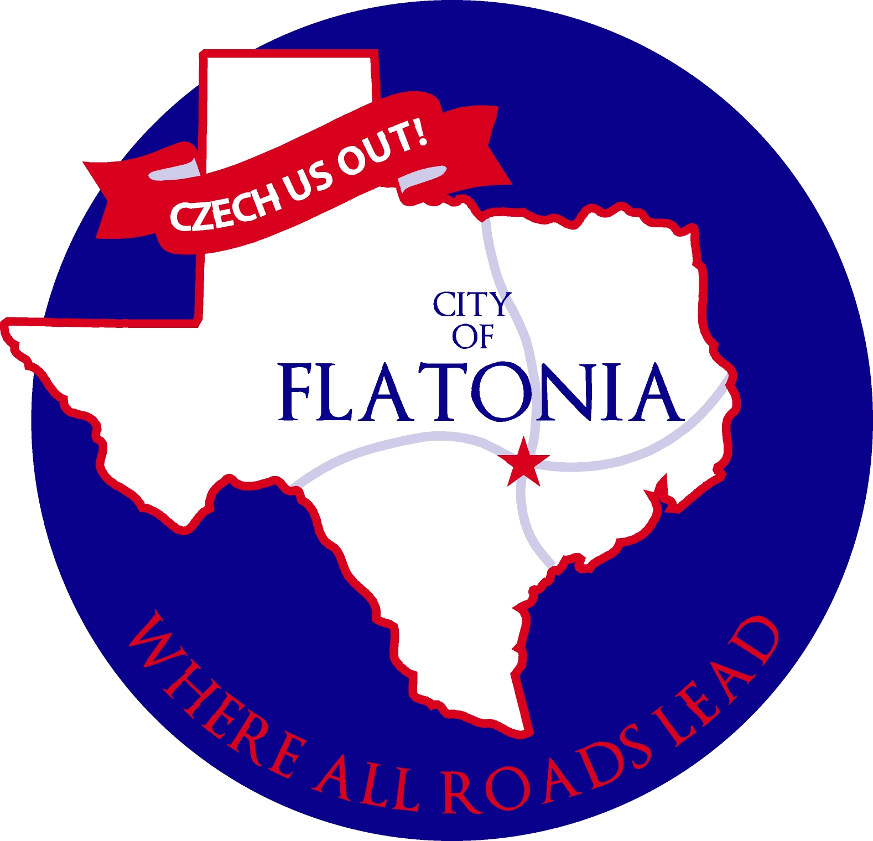

Notice of Flatonia Parks Committee Meeting

In accordance with the provisions of the Texas Open Meetings Act, Chapter 551, Texas Government Code, Notice is hereby given that a Regular Meeting of the City of Flatonia Parks Committee will be held on Wednesday, November 15, 2023, beginning at 6:00 p.m. in the City Hall Council Chambers located at 125 E. South Main St., Flatonia, Texas, for the purpose of considering the following agenda items:

Opening Agenda
Call to Order
Citizens Participation

Consent Agenda
C1. Approve minutes from the regular meeting on August 23, 2023.

Discussion
D1. Discuss the new driveway at McWhirter Park.

D2. Discuss the addition of lighting and the potential name change of Memorial Park.

D3. Discuss the addition of little league fields at 7 Acre Park.

D4. Discuss the ballfields update at McWhirter Park.

D5. Discuss the restroom update at Garbade Park.

D6. Discuss the swimming pool repairs at 7 Acre Park.

D7. Discuss repainting the stripes on the basketball court at 7 Acre Park.

D8. Discuss the City Hall Christmas tree provided by the Rotary Club.

Adjournment

I, the undersigned authority hereby certify that the Notice of Meeting was posted on the bulletin board outside the front door of the City Hall of the City of Flatonia, Texas, a place convenient and readily accessible to the public at all times and said Notice was posted on the following date and time: November 10, 2023, by 5:00 p.m. and remained so posted continuously for at least 72 hours preceding the scheduled time of said meeting.

Jacqueline Ott, City Secretary, City of Flatonia

NOTICE OF ASSISTANCE
AT THE PUBLIC MEETING

The Flatonia City Hall is wheelchair accessible. Access to the building is available at the primary entrance facing Main Street. Persons with disabilities who plan to attend this meeting and who may need auxiliary aids or services such as interpreters for persons who are deaf or hearing impaired, readers, or large print are requested to contact the City Secretary’s Office at 361-865-3548 or by FAX 361-865-2817 at least two working days prior to the meeting so that appropriate arrangements can be made.
EXECUTIVE SESSION STATEMENT

The Parks Committee reserves the right to adjourn into executive session at any time during the course of this meeting to discuss any of the matters listed above, as authorized by the Texas Government Code, Section 551.071 (Consultations with Attorney), 551.072 (Deliberations about Real Property), 551.073 (Deliberations Regarding Gifts and Donations), 551.074 (Personnel Matters), 551.076 (Deliberations Regarding Security Devices or Security Audits), 551.086 (Certain Public Power Utilities: Competitive Matters) and 551.087 (Deliberation Regarding Economic Development Negotiations).

Agenda Removal Notice
This Public Notice was removed from the official posting board.
at the Flatonia City Hall on the following date and time:

By:
Jacqueline Ott
City Secretary, City of Flatonia

