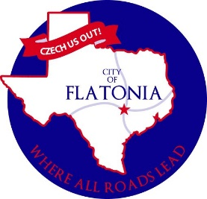

CITY OF FLATONIA

SPECIAL CITY COUNCIL MEETING

Council Chambers/City Hall

125 E. South Main, Flatonia, Texas

October 16, 2023 at 5:00 p.m.

AGENDA
Opening Agenda

Call to Order
Invocation & Pledge
Citizens’ Participation

Deliberation Agenda

DA10.2.2023.1 Consider and take appropriate action to reject bids received for the CDBG CDV21-0342 grant on September 29, 2023.

Adjournment

I, the undersigned authority do hereby certify that the Notice of Meeting was posted on the bulletin board outside the front door of the City Hall of the City of Flatonia, Texas, a place convenient and readily accessible to the general public at all times and said Notice was posted on the following date and time October 12, 2023, by 5:00 p.m. and remained so posted continuously for at least 72 hours preceding the scheduled time of said meeting.

Jacqueline Ott, City Secretary, City of Flatonia

NOTICE OF ASSISTANCE
AT THE PUBLIC MEETING

The Flatonia City Hall is wheelchair accessible. Access to the building is available at the primary entrance facing Main Street. Persons with disabilities who plan to attend this meeting and who may need auxiliary aids or services such as interpreters for persons who are deaf or hearing impaired, readers, or large print are requested to contact the City Secretary’s Office at 361-865-3548 or by FAX 361-865-2817 at least two working days prior to the meeting so that appropriate arrangements can be made.
EXECUTIVE SESSION STATEMENT

The City Council reserves the right to adjourn into executive session at any time during the course of this meeting to discuss any of the matters listed above, as authorized by the Texas Government Code, Section 551.071 (Consultations with Attorney), 551.072 (Deliberations about Real Property), 551.073 (Deliberations Regarding Gifts and Donations), 551.074 (Personnel Matters), 551.076 (Deliberations Regarding Security Devices or Security Audits), 551.086 (Certain Public Power Utilities: Competitive Matters) and 551.087 (Deliberation Regarding Economic Development Negotiations).
Agenda Removal Notice
This Public Notice was removed from the official posting board at the Flatonia City Hall on the following date and time:

By:
Jacqueline Ott,
City Secretary, City of Flatonia

