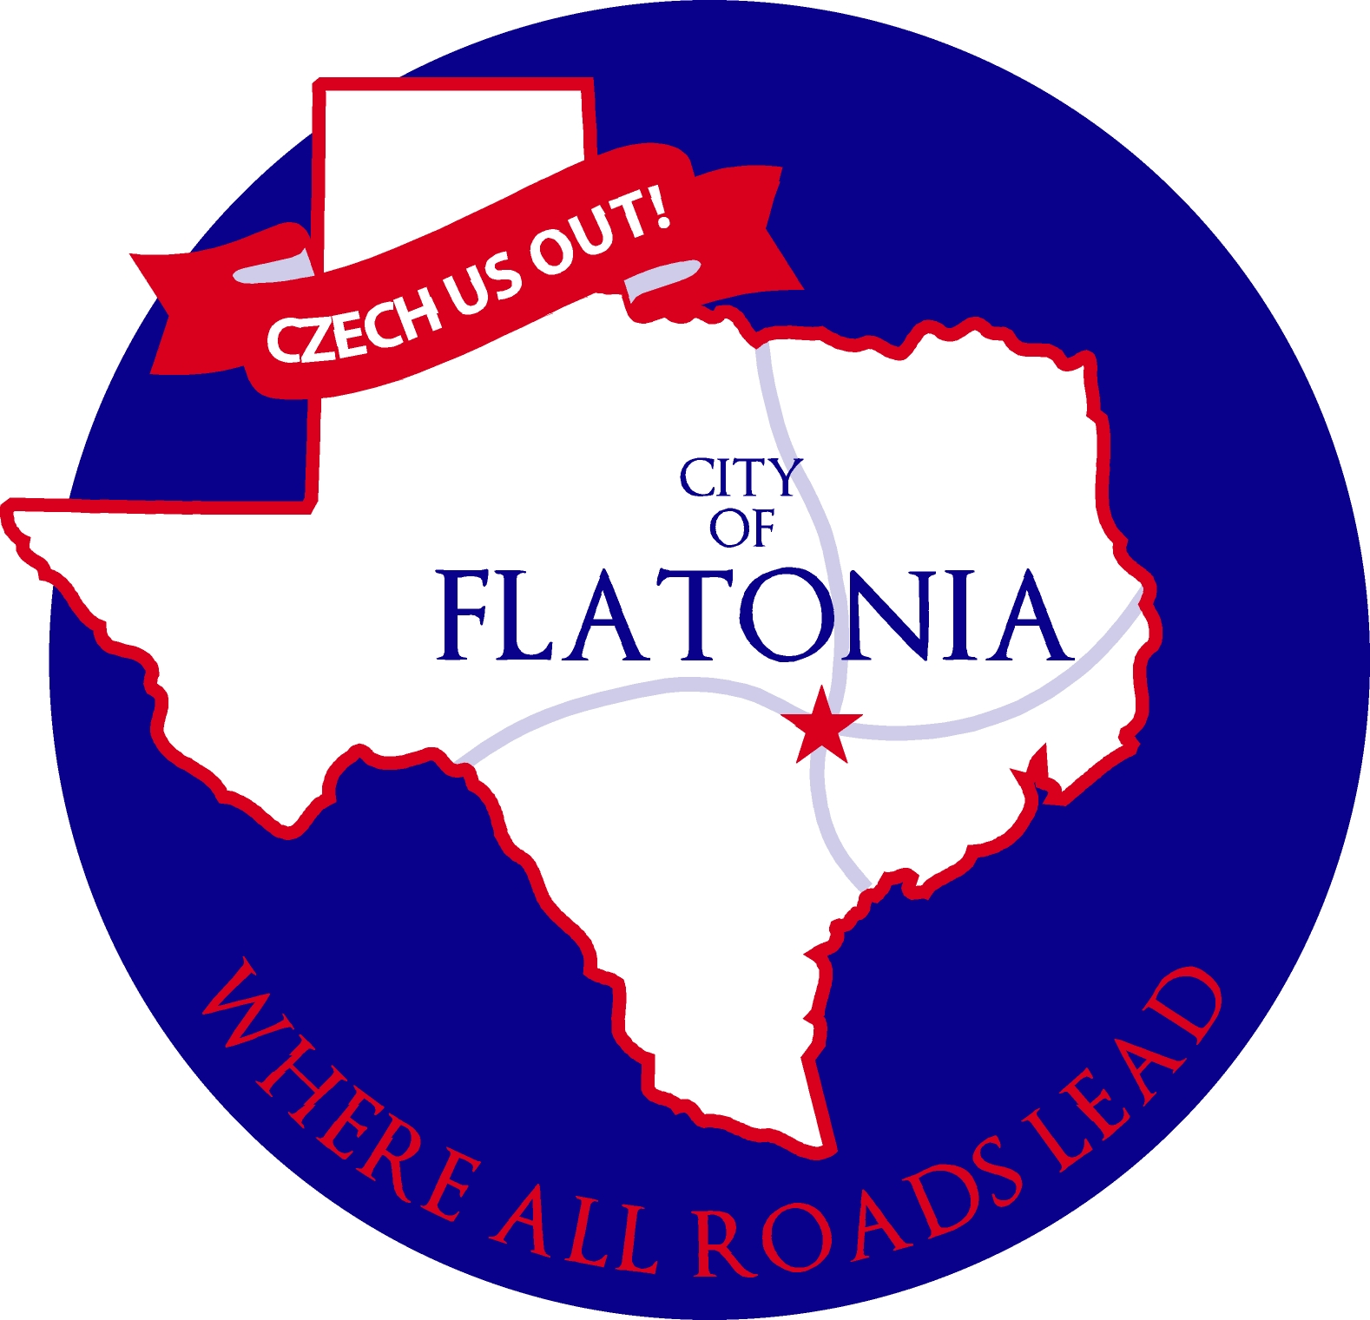

Notice of Economic Development Corporation Regular Board Meeting

In accordance with the provisions of the Texas Open Meetings Act, Chapter 551, Texas Government Code, Notice is hereby given that an Economic Development Corporation Board Meeting will be held on Thursday, October 26, 2023, beginning at 6:00 p.m. in the City Hall Council Chambers located at 125 E. South Main St., Flatonia, Texas, for the purpose of considering the following agenda items:

The meeting agenda is posted online at: http://www.flatoniatx.gov/page/edc_agendas_minutes.
Members of the public who wish to submit their written questions or comments on an upcoming agenda item must submit these by sending an email to City Secretary Jacqueline Ott at citysecretary@ci.flatonia.tx.us. Questions or comments must be received no later than noon on Monday, November 6, 2023.

Opening Agenda

Call to Order
Invocation & Pledge

Citizens’ Participation

Consent Agenda
C1. Motion to approve minutes from the September 14, 2023, EDC meeting.
C2. Motion to approve minutes from the October 4, 2023, EDC meeting.

Discussion Agenda
D1. Discuss the construction progress on the restrooms at 7 Acre Park.
D2. Discuss the increased cost of the swimming pool repair.
D3. Discuss the Façade Improvement Grant applications.
D4. Discuss Tesla charging stations added to Exhibit A in order of priority.
D5. Discuss ordering yard signs for EDC projects.

Workshop
WS10-2023.2
Potential projects and opportunities to improve Economic Development for the City of Flatonia in accordance with the Bylaws of the Flatonia Economic Development Corporation and governed by Local Government Code, Chapter 501-Provisions Governing Development Corporations, and Chapter 505-Type B Corporations.

Reports
YTD Financial Report of the Economic Development Corporation

Deliberation Agenda
DA10.2.2023.1 Consider and take appropriate action to add Tesla charging stations to Exhibit A list of potential EDC projects in order of priority.

DA10.2.2023.2 Consider and take appropriate action to remove the wastewater treatment plant backup generator from Exhibit A list of potential EDC projects.

DA10.2.2023.3 Consider and take appropriate action to move $10,000 from the capital outlay account number 4220.4007 (budget amount $20,000) “drive through/demo Grifaldo house” to a new budget line item “swimming pool repair.”

DA10.2.2023.4 Consider and take appropriate action to approve allocating funds to repair the swimming pool.

DA10.2.2023.5 Consider and take appropriate action to place $90,000 in an interest-bearing bank CD at First National Bank of Shiner for nine (9) months.

DA10.2.2023.6 Consider and take appropriate action to approve registration fees for President Sears and Committee member Geesaman to attend the TML conference at Lost Pines on November 16-17, 2023.
Adjournment

I, the undersigned authority hereby certify that the Notice of Meeting was posted on the bulletin board outside the front door of the City Hall of the City of Flatonia, Texas, a place convenient and readily accessible to the general public at all times and said Notice was posted on the following date and time: October 23, 2023, by 5:00 p.m. and remained so posted continuously for at least 72 hours preceding the scheduled time of said meeting.

Jacqueline Ott, City Secretary, City of Flatonia

NOTICE OF ASSISTANCE
AT THE PUBLIC MEETING

The Flatonia City Hall is wheelchair accessible. Access to the building is available at the primary entrance facing Main Street. Persons with disabilities who plan to attend this meeting and who may need auxiliary aids or services such as interpreters for persons who are deaf or hearing impaired, readers, or large print are requested to contact the City Secretary’s Office at 361-865-3548 or by FAX 361-865-2817 at least two working days prior to the meeting so that appropriate arrangements can be made.
EXECUTIVE SESSION STATEMENT

The City Council reserves the right to adjourn into executive session at any time during the course of this meeting to discuss any of the matters listed above, as authorized by the Texas Government Code, Section 551.071 (Consultations with Attorney), 551.072 (Deliberations about Real Property), 551.073 (Deliberations Regarding Gifts and Donations), 551.074 (Personnel Matters), 551.076 (Deliberations Regarding Security Devices or Security Audits), 551.086 (Certain Public Power Utilities: Competitive Matters) and 551.087 (Deliberation Regarding Economic Development Negotiations).

Agenda Removal Notice
This Public Notice was removed from the official posting board at the Flatonia City Hall on the following date and time:

By:
Jacqueline Ott
City Secretary, City of Flatonia

